Data Loading (ETL) assignment

Q1. Data Understanding Identify all data quality issues present in the dataset that can cause problems during data loading.

Answer
- Duplicate Records: Order_ID O101 appears twice with identical values.
- Missing Values: Sales_Amount is Null for Order_ID O102.
- Inconsistent Data Types: Sales_Amount has text "Three Thousand" instead of numeric for Order_ID O104.
- Date Format Inconsistency: Dates are in DD-MM-YYYY and YYYY/MM/DD.
- Primary Key Violation: Duplicate Order_ID breaks uniqueness.

Q2. Primary Key Validation Assume is the Primary Key.
- Is the dataset violating the Primary Key rule?
- Which record(s) cause this violation?

- Yes, dataset violating the primary key rule.
- Record causes violation:
O101 (Order_ID, Customer_ID, Sales_Amount, Order_Date).

Q3. Missing Value Analysis Which column(s) contain missing values?
- List the affected records
- Explain why loading these records without handling missing values is risky

Answer
- List the affected records = sales_amount ('O102', 'C002', NULL, '2024-01-15')
- Explain why loading these records without handling missing values is risky
- Incorrect aggregations in BI dashboards.
- Errors in SQL queries if column is set as NOT NULL.
- Misleading KPIs (e.g., lower total sales).

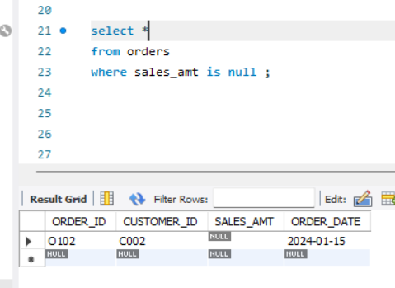

Q4. Data Type Validation
Identify records where Sales_Amount violates expected data type rules.
a) Which record(s) will fail numeric validation?
b) What would happen if this dataset is loaded into a SQL table with as decimal?

Answer
a) Which record(s) will fail numeric validation?
Order_ID O104 → Sales_Amt = "Three Thousand"

b) What would happen if this dataset is loaded into a SQL table with as decimal?
- This record will fail insertion or cause conversion errors.
- ETL job may abort or skip the record.
- Load fails completely.

Q5. Date Format Consistency
The order_date column has multiple formats.
a) List all date formats present in the dataset?
b) Why is this a problem during data loading?

Answer
a) List all date formats present in the dataset?
- DD-MM-YYYY = 12-01-2024, 15-01-2024, 20-01-2024, 25-01-2024.
- YYYY/MM/DD = 2024/01/18.
b) Why is this a problem during data loading?
- SQL/BI tools expect consistent date format.
- Mixed formats cause parsing errors, incorrect sorting, and wrong aggregations.
- Dates can be interpreted incorrectly.

Q6. Load Readiness Decision Based on the dataset condition:
  - Should this dataset be loaded directly into the database? (Yes/No).
  - Justify your answer with at least three reasons

Answer
- No, Dataset cannot loaded directly into the database.
- Reasons.
- Multiple date formats.
- Data will be misinterpreted. (O104)
- Null/ missing values.
- Duplicate primary key. (O101)
- Missing sales_amount. (O102)

Q7. Pre-Load Validation Checklist List the exact pre-load validation checks you would perform on this dataset before loading.

Answer
Pre-Load Validation means data management system data checked for accuracy, completeness and formatting before it is permanently saved or transferred into a new system.

- Primary key uniqueness check.
- Null value detection.
- Schema validation.
- Duplicate check.
- Data type check.
- Range/boundary check.
- Row count check.
- Format consistency.
- Encoding check.
- Business rule check.
- Date format standardization.
- Duplicate record removal.

Q8. Cleaning Strategy Describe the step-by-step cleaning actions required to make this dataset load-ready.
Answer
- Remove Duplicates → Keep one record for O101.
- Handle Nulls → Impute Sales_Amount for O102 (average, median, or flag).
- Convert Text to Numeric → "Three Thousand" → 3000.
- Standardize Dates → Convert all to YYYY-MM-DD.
- Validate Business Rules → Ensure Sales_Amount > 0.
- Correct invalid values.
- Standardized categories.
- Trim whitespace.

Q9. Loading Strategy Selection Assume this dataset represents daily sales data. a) Should a Full Load or Incremental Load be used?
b) Justify your choice.

Answer
a) Use Incremental Load. Its use for only new or updated records.

b) Justification:
- Dataset represents daily sales.
- Incremental load avoids reloading entire history.
- Saves time and resources, ensures only new/changed records are loaded.
- Faster execution.
- Less system load.
- Safer than full load.

Q10. BI Impact Scenario Assume this dataset was loaded without cleaning and connected to a BI dashboard.
a) What incorrect results might appear in Total Sales KPI?
b) Which records specifically would cause misleading insights?
c) Why would BI tools not detect these issues automatically?

Answer
a) Incorrect KPI results:
- Total Sales inflated due to duplicate O101.
- Underreported due to missing Sales_Amount (O102).
- Miscalculated due to text "Three Thousand".
- Incorrect date filtering.
b) Problematic Records:
- O101, O102, O104.
- Negative sales amount.
- Wrong date format .
- Duplicate orders IDs.
c) BI tools won’t detect issues because:
- They assume data is clean.
- Aggregations run blindly on loaded values.
- No built-in validation for duplicates, nulls, or type mismatches.
- Bi tools no knowledge of business rules.
- Null values are silently ignored.
- Type of mismatched.

